Todo and notes

Winter 2023 TA’s

Zixin Zeng, 10am

Grace Coram, 11am

Printing the whole document, there are lines interfering with text in preface and TOC, all need formatting

Feedback

I have read over Chapters 3 and 4. Overall, they seem very clear! There are a couple typos/mistakes I caught -- one on p. 42 "this chapters" and one on p. 72 where "areas" is spelled "ares." The only other comment I have would be on the introductory section of Chapter 3 on page 44. While most of the terms of interest are explained enough for students to get a preliminary understanding heading into the chapter, reliability and validity are not as well-defined. While they are explained in better detail later, this first peak doesn't clarify how they differ and I think those two may be easily mixed up. It may be helpful to add a sentence or two making their differences more clear in this first introductory section. It is probably not a serious issue as they are explained later but I thought I would mention it!

Thanks!

Grace

I have looked over the chapters. Aside from some formatting things like you mentioned (numbered lists on pages 27 and 34 having different indent levels than the rest of the text, gaps between text and text boxes on pages 14, 16, 20, 38, and 48 of the pdf) I think the contact is easily digestible and I didn't find any large errors! The formatting issues are not super distracting nor do they take away from the content but I thought I would mention them anyway.

Zixin

Feedback on PSYCH205 textbook draft

12/08/2023

● Formatting

I think textbooks usually use justify alignment for text (instead of left align).

The purple squares for additional content have large fonts, and the space between the purple section and other text is a bit wide.

Abbreviations in the table of contents might be confusing to readers unfamiliar with research design. For example, ANOVA, IV.

Add page number for each chapter for easy access in the table of contents.

Highlight the key terms just once.

Bottom figure on page 10 & 11, chapter 1 incomplete. Consider putting the three paragraphs about materials in the paragraphs together. It might be helpful to separate the procedure and the materials in two subsections, instead of mixing them together.

The use of “” and ‘’ are not consistent in text.

● Potential typos

sub-title -> subtitle (page 2, preface)

slight -> slightly (page 4, preface)

Students t-test -> Students’ t-test (table of contents)

managine -> managing (table of contents)

Chi2 -> Chi-squared test (or use the Greek alphabet for Chi-square)

on a 1-5 scale from “very much” to “not at all” -> on a 1-5 scale from “not at all” to “very much”

(page 3, chapter 1)

Operation definition -> operational definition (page 3, chapter 1)

Work list -> word list (page 4, chapter 1)

quantitative number: are there non-quantitative numbers?(page 4, chapter 1)

‘old’ -> “old” (page 4, chapter 1) etc.

Chapter 2 will discuss operational definitions as an example of Measurement

Theory -> period missing (page 16, chapter 1)

To highlight this different -> difference(page 19, chapter 1)

but should be noted -> but it should … (page 23, chapter 2)

A overview -> An overview (page 23, chapter 2)

Stevens’s levels -> Stevens’ levels (page 36, chapter 2)

that us unrelated -> that is unrelated (page 37, chapter 2)

Obtaining data that argues for single or multiple types of intelligence turns out to be extremely challenging -> missing period (page 38, chapter 2)

● Content

I find the sections of “Hands-on Research Methods” a little confusing. The sections are called “Experiment 1”, but a lot of the paragraphs are descriptions of the chapters, not directly related to the experiment. Consider putting experiment descriptions together, and have a separate section for chapter overview.

Constance (table of contents): what does this mean? I searched online but could not find a relevant definition in statistics or research design.

I think it’s a good idea to list all the important questions as a list (e.g. What is the IV) before we go into the details. Currently they are on page 15, but can be moved to page 2. “higher level of depth”: probably would be clearer to say “depth of encoding” or “encoding depth”? (page 4, chapter 1)

I would put the which clauses (e.g. which are based on operational definitions) inside

parentheses so it’s easier to read. (page 6, chapter 1)

What does XKCD (in figure title) mean on page 9, chapter 1?

Instead of saying “Experimental vs Non-Experimental Research”, it might be helpful to view the different methods on a spectrum with different levels of control.

“For example, if one temperature is twice as high as another as measured on the Kelvin scale, then it has twice the kinetic energy of the other temperature.”: kinetic energy is the property of objects, not the temperature itself.

General note: some of the sentences in the manuscript include multiple “that” clauses, which makes the sentences harder to read. For example, “It has become particularly clear in recent years *that* this second point is an important element of critical thinking about science *that* has been a particular challenge for the general populace.” Also “Stating the opposite, *that* counting vowels will lead to higher recognition scores compared with rating liking is also an equally valid hypothesis, although we will see *that it is false*. *That is*, it is not supported by the data.” And “It would also be fair to say *that* any measure of memory for a list of arbitrary, unrelated words fails to capture important ideas *that* people are interested in *that* relate to the concept of memory.”

Formatting

Add sub-title text style for multi-line chapter titles – seems impossible?

Add another subheading level --- ?

References from chapters all deleted for now…

Annotated pdf’s of Craik & Lockhart (1972) and Craik & Tulving (1975) for assignments

Define Framework theory somewhere in Chapter 1 or 2?

Edit 1 & 2 using feedback from Grace and Zixin, checking formatting

Chapter 3 and 4 feedback

Chapter 5

Make formulas as images in ppt

Screen shot captures of software

Redo Excel sections using Google Sheets as freeware

Replicability crisis inset for opening section

Chapter 5: formulas are all broken in statistics

Chapter 6: incorporating the sample publication document

Formatting somewhat messed up

Chapter 7: Within participant designs

More experimental control, repeating levels of the IV and all the potential history effects that can occur

Chapter 8: Ethics

Chapter 1

Chapter 2

Fix text inset boxes with Ch1

Chapter 3

Chapter 4

Test boxes, add figures

Chapter 5

Statistics images, figures

Parallel statistical workthrough with Google Sheets instead of Excel

Chapter 6

Learning objectives

Annotated sample report pdf for additional reference

Figures

Chapter 7

Learning objectives

Within participants design examples

Exercises

Chapter 8

Exercises

<https://xkcd.com/435/>

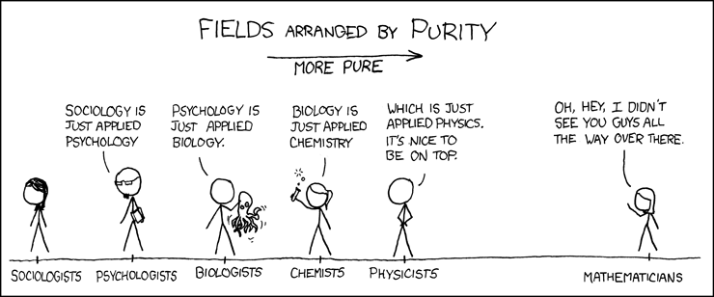

<https://xkcd.com/882/>

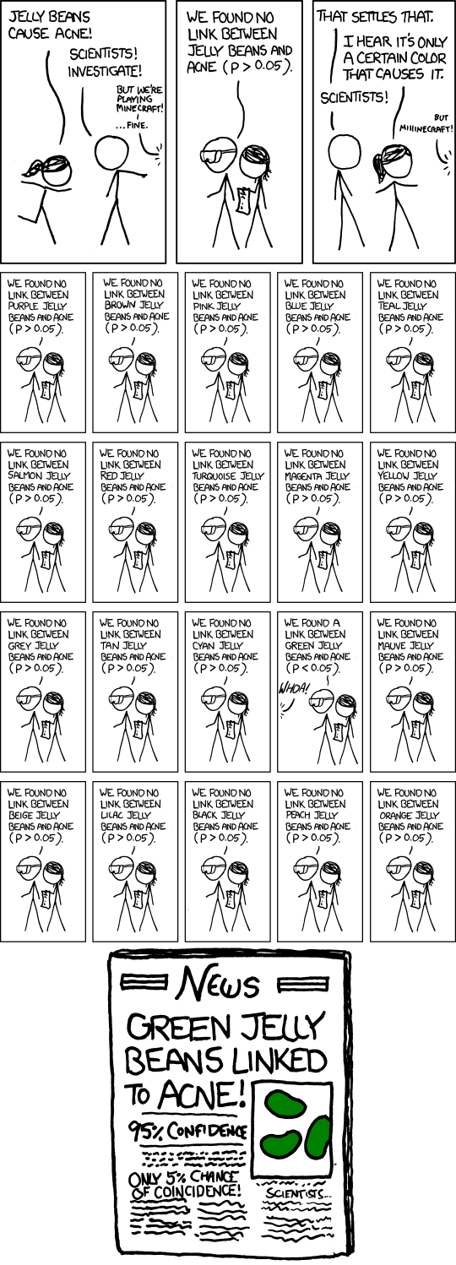

<https://xkcd.com/1895/>

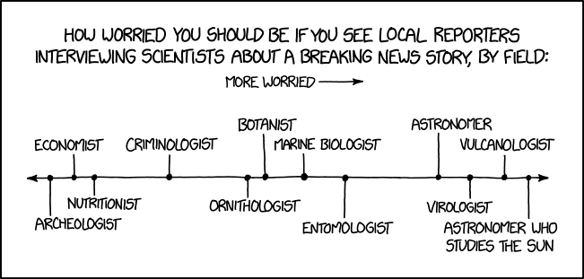

<https://xkcd.com/2456/>

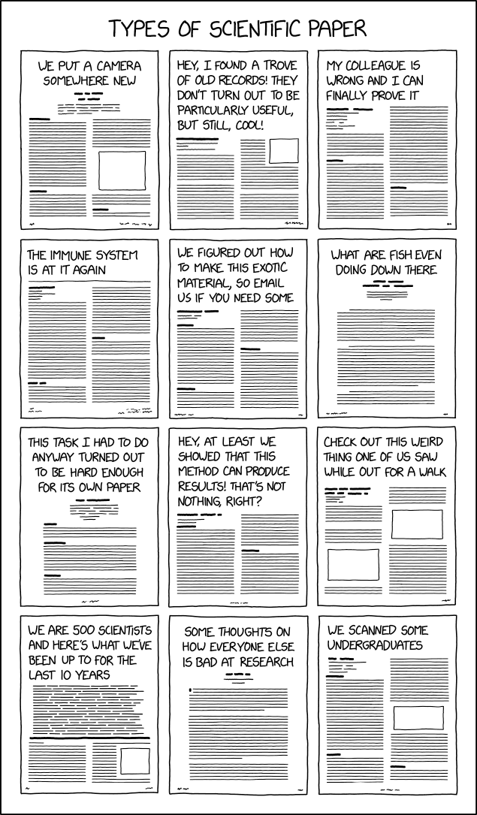

<https://xkcd.com/1574/>

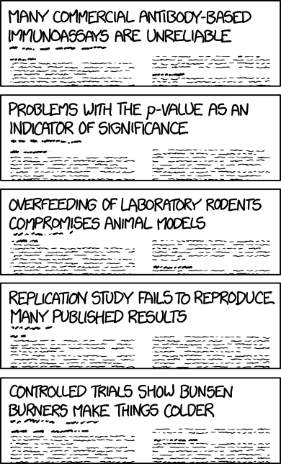

<https://xkcd.com/2501/>

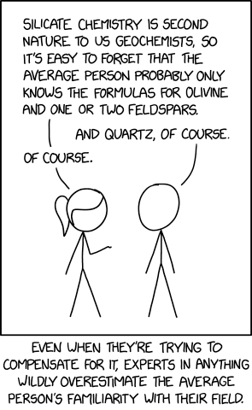

<https://xkcd.com/749/>

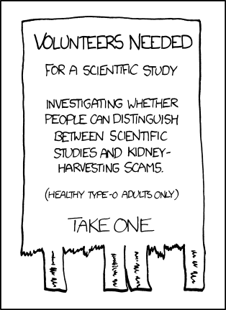

<https://xkcd.com/2569/>

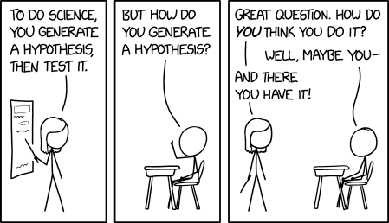

<https://xkcd.com/385/>

